EE 382 Lab 5 FM and PM Modtulation.



By. Christopher W. Fingers

Professor Morshad

EE 382 Tuesday and Thursday 3:30 pm – 5:30 pm.

Part 1 FM modulation

KF = 80 and not set to 160pi.

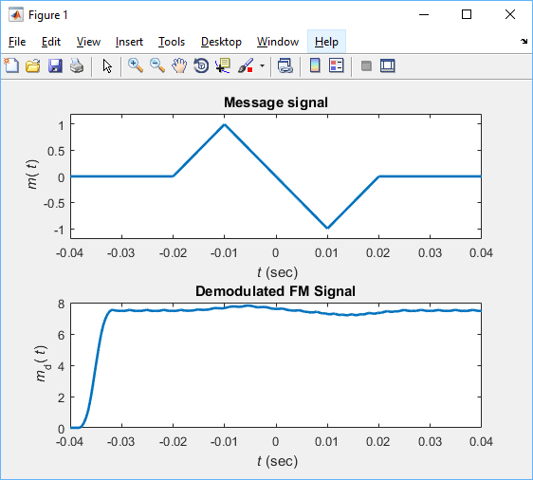

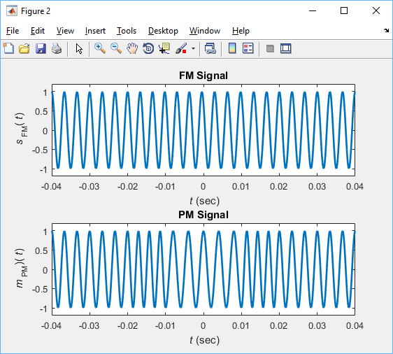

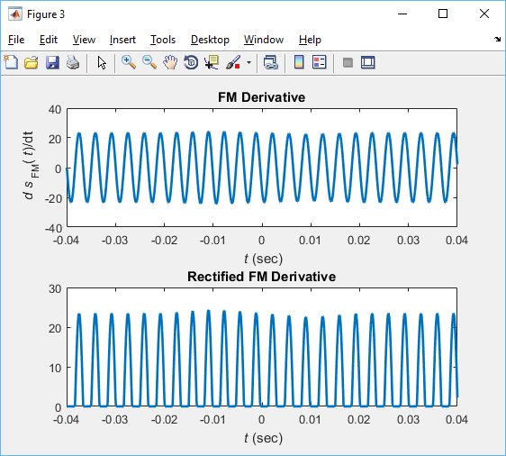

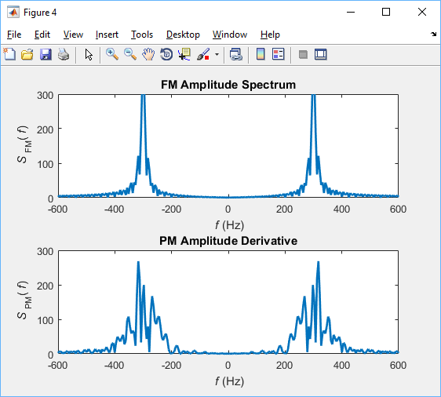

Part 2:

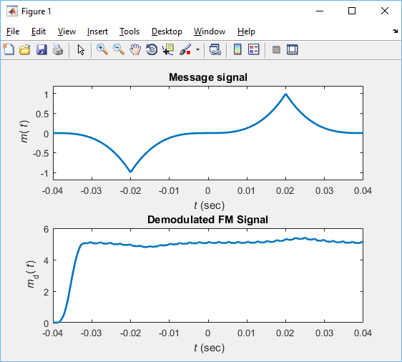

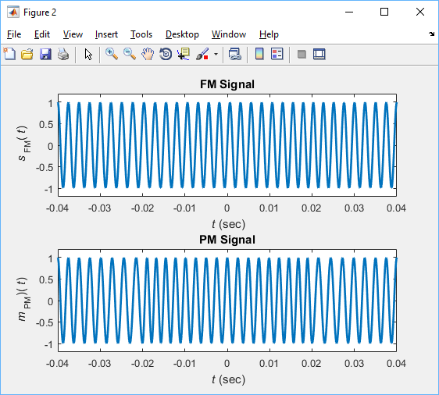

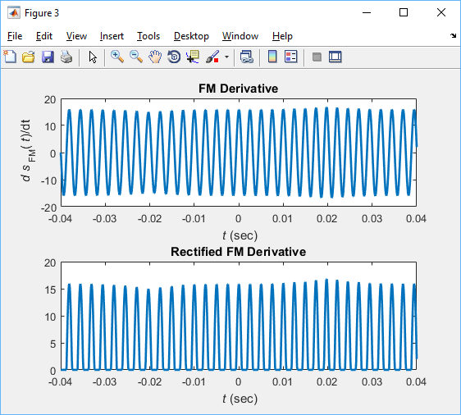

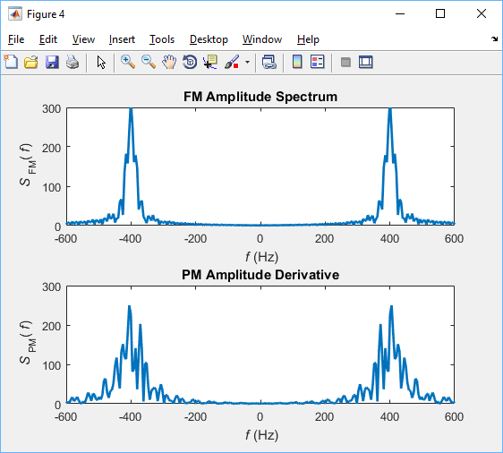

Part 3:

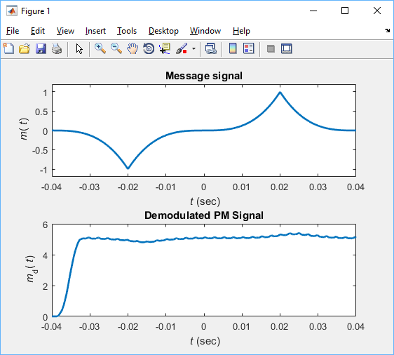

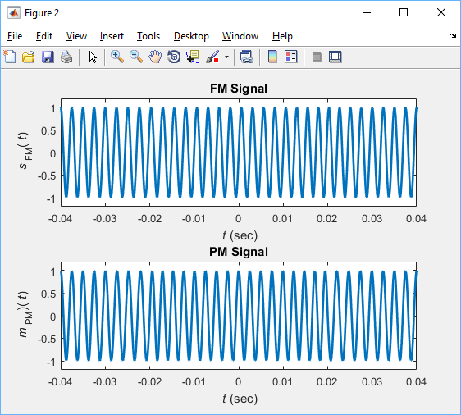

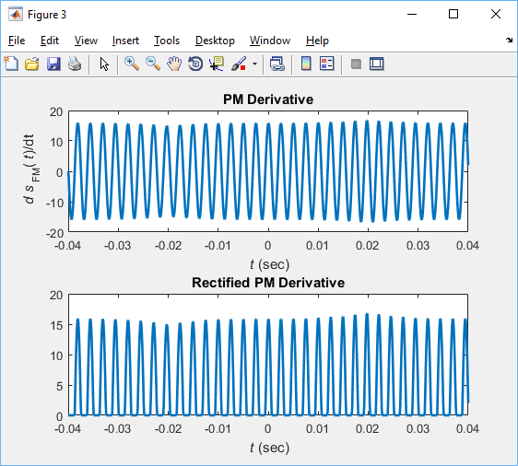

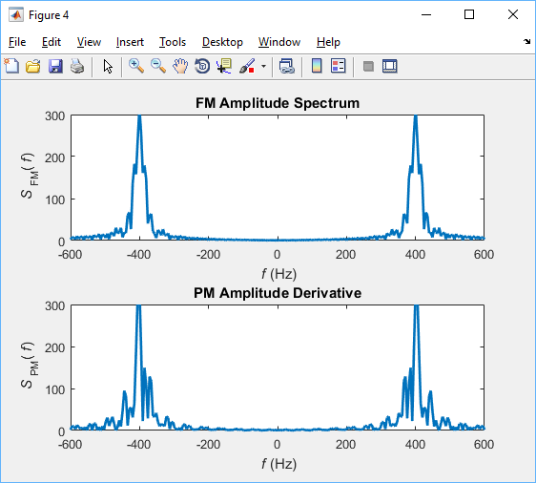

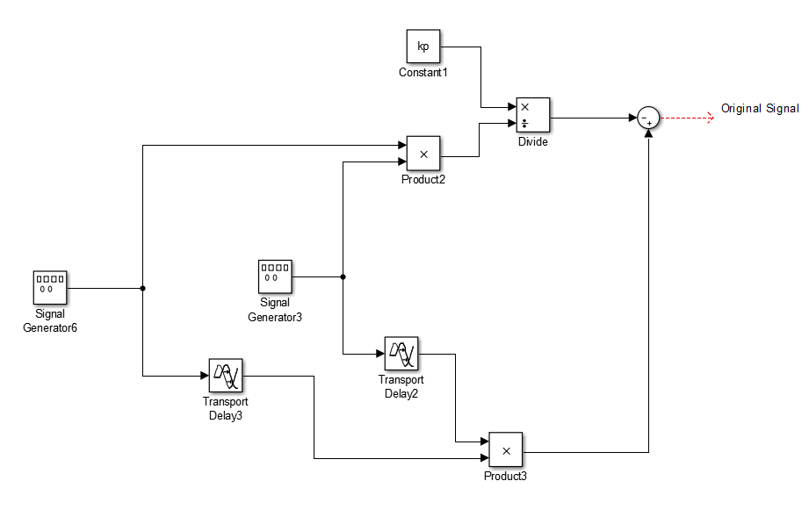

Additional elements to receive original PM signal.

Simulink

Part 1:

Messenger Frequency = 10kHz

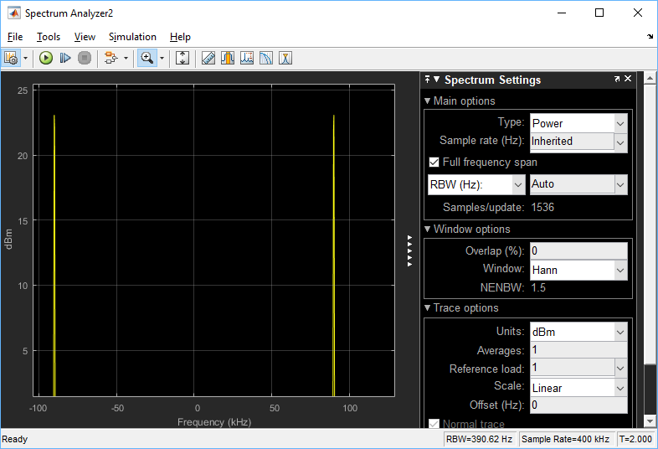

LSB Power (DBM)

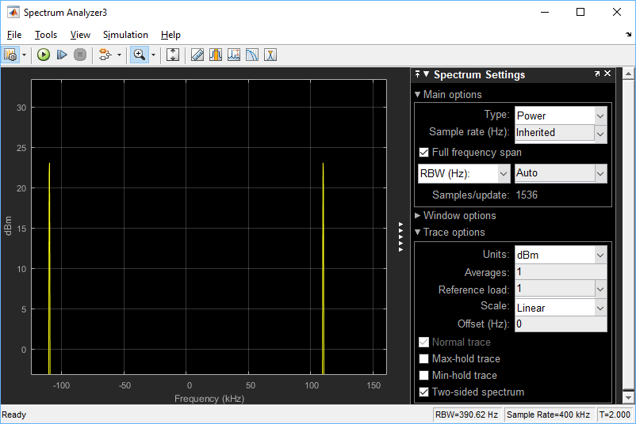

USB Power (DBM)

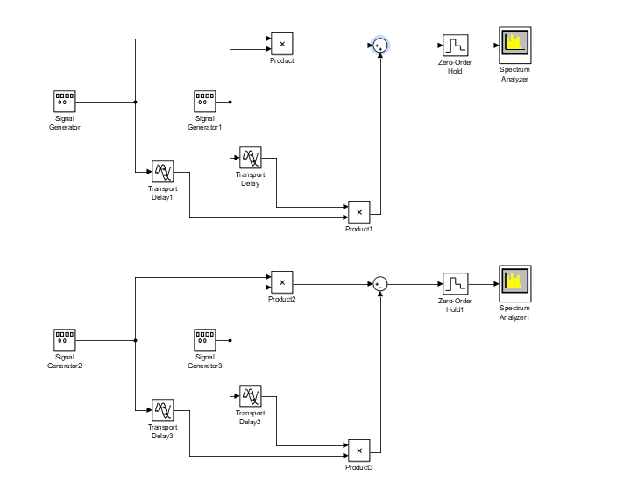

USB/LSB Set up.

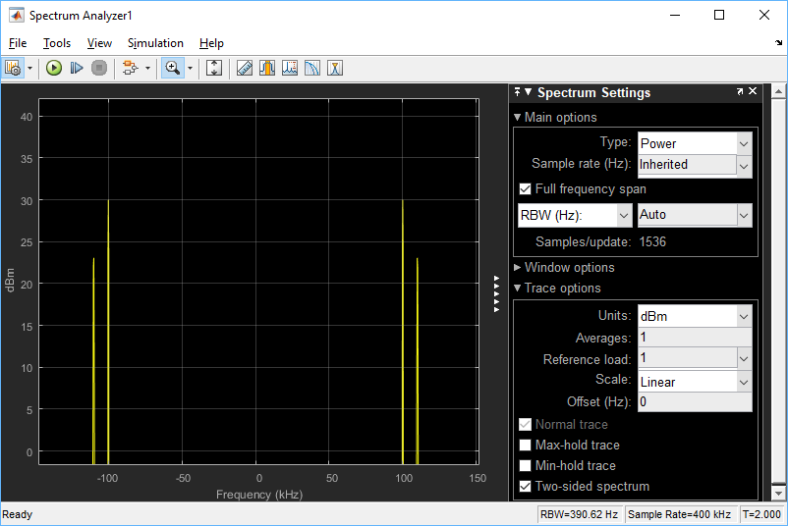

USB+C A = 2. Power (DBM).

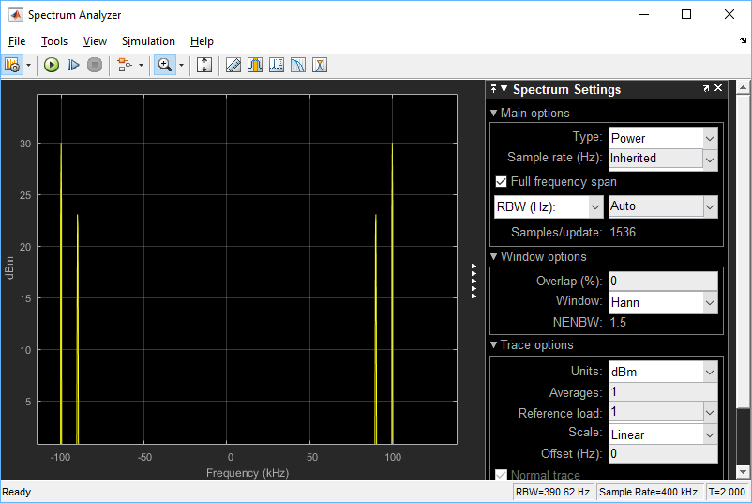

LSB A=2. Power (Dbm).

3. Envelope Detector

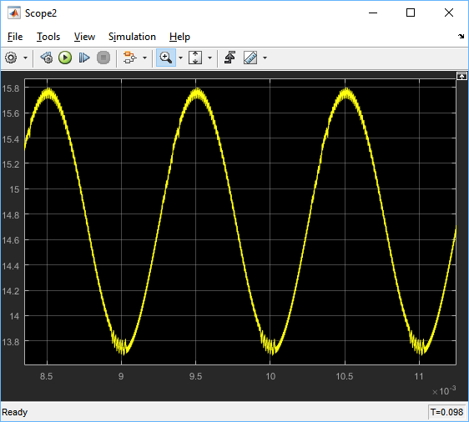

A was set to 15 in this cause. The envelope is just barely off of 16, however with m(t)’s gain set to 1, this shows that the envelope of the signal is approximately equal to A+m(t).

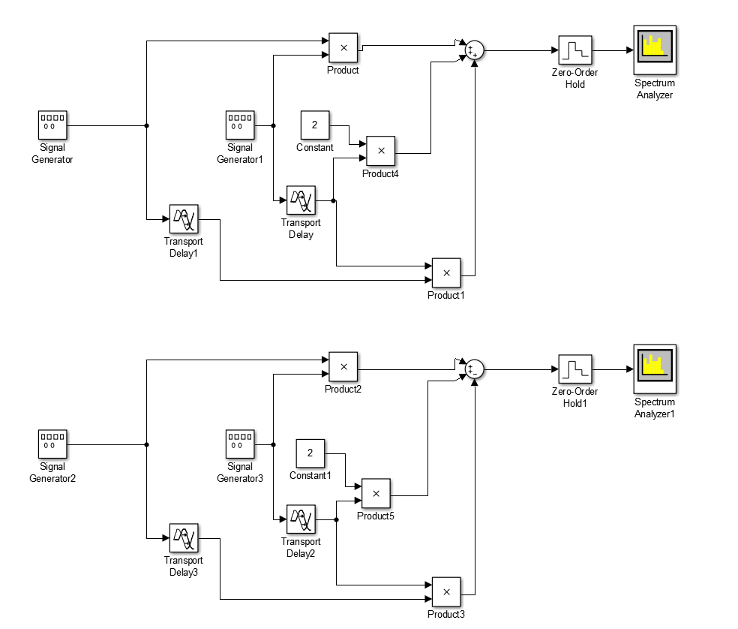

SSB+C Schematic.

Part 3:

M1(t) = 3sin(2*pi*800*t); M2(t)=10sin(2*pi*2000*t)

Recovered M1(t):

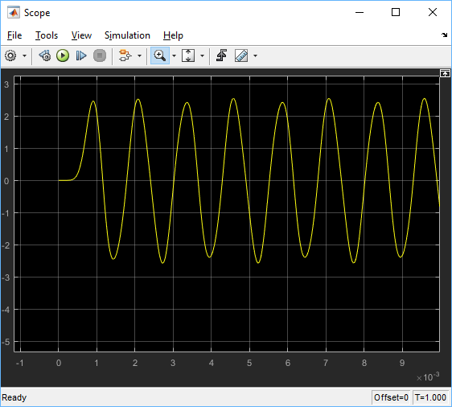

Recovered M1(t)

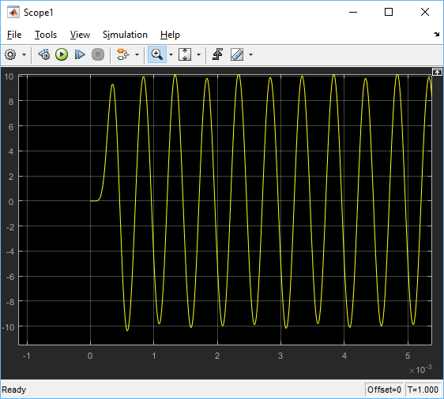

Recovered M2(t)

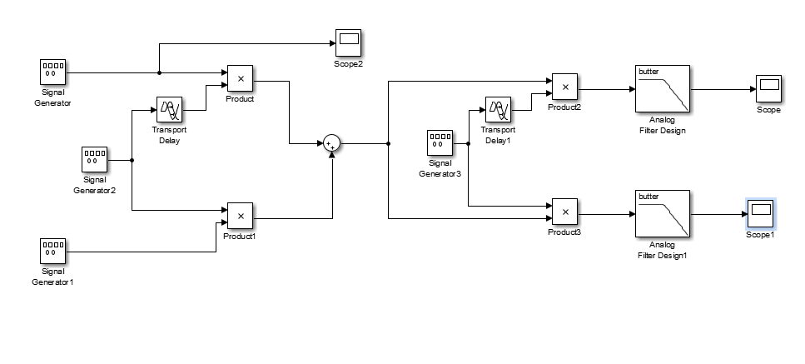

Quadrature AM Mod-Demod model

Part 5

Frequency for messenger same as first model, 10,000 hertz. Carrier 100000

1. Narrow Bandpass Pm. Kp = pi,

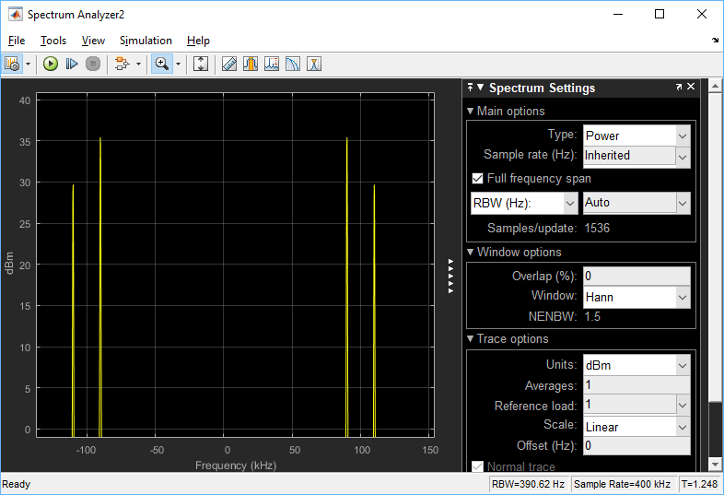

FM. Kf = 50pi

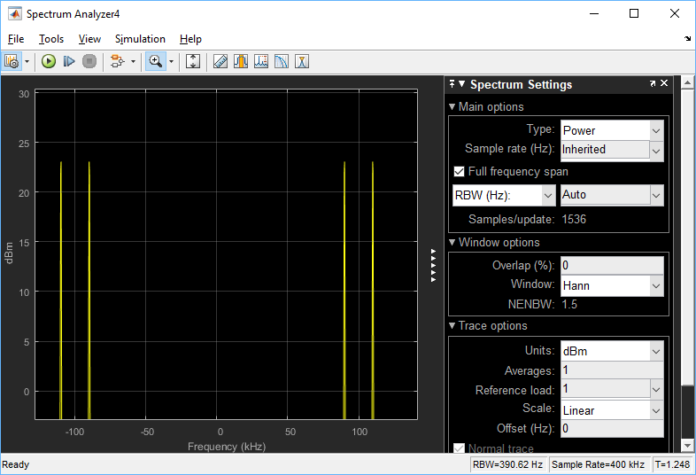

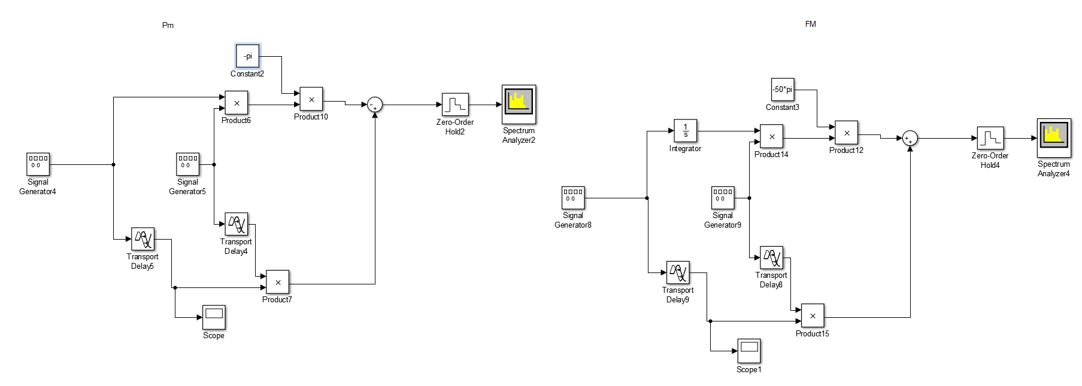

Narrow BandPass Pm and FM schematic.

1. Frequency Doubled for model 1.

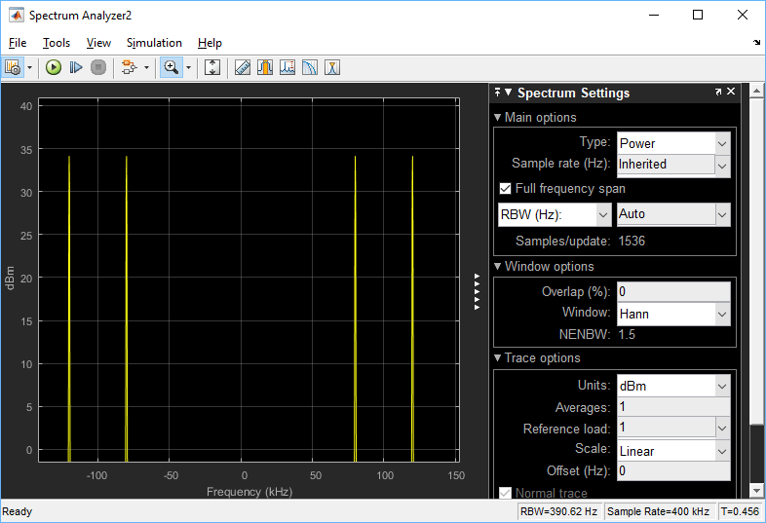

PM

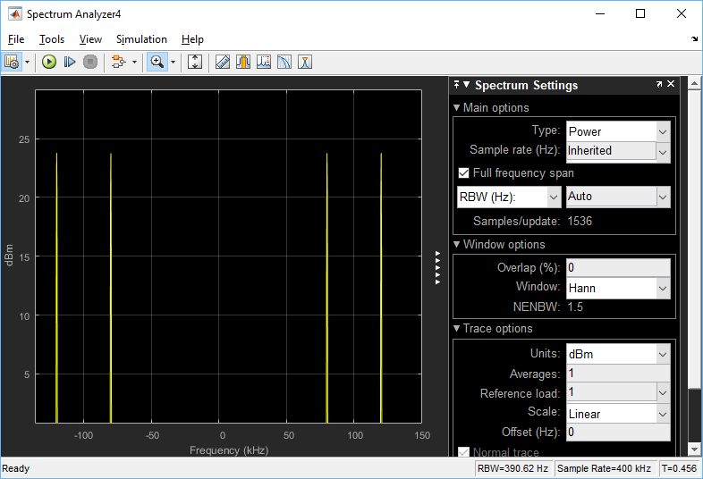

FM

Frequency Tripled

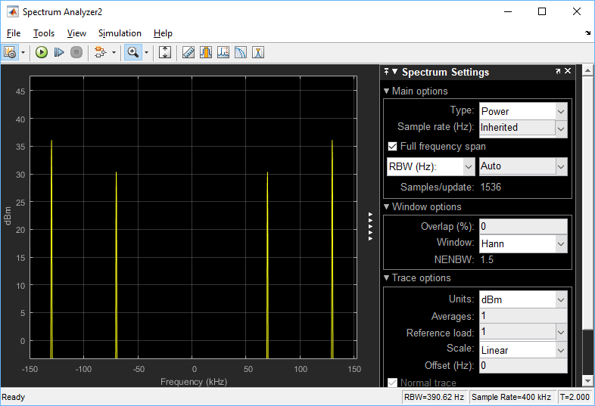

PM

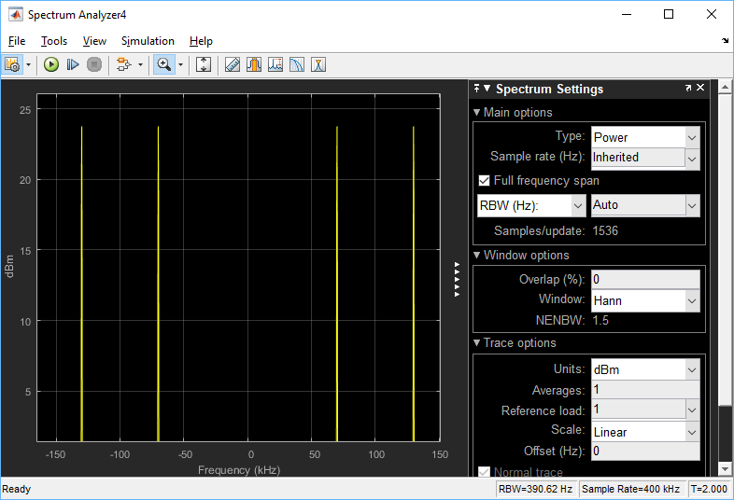

FM

As the frequency of the system was increased by a factor of 2 and 3, the bandwidth between the points was increasing with a similar factor.

1. Hard Limiter/ Band Pass

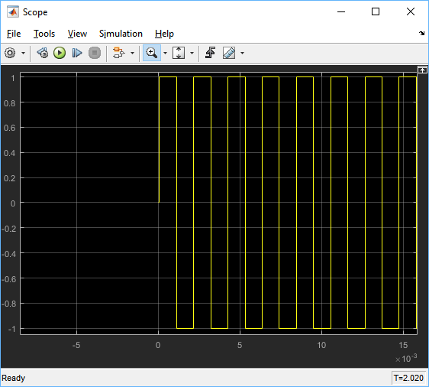

Hard Limiter

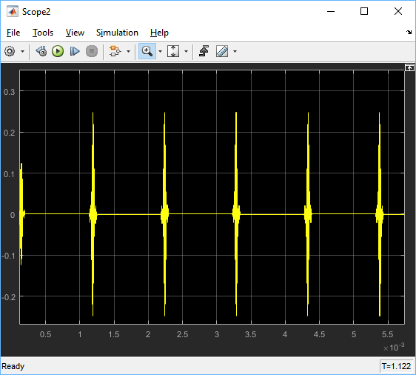

Bandpass Filter

1. Differentiator and Envelope

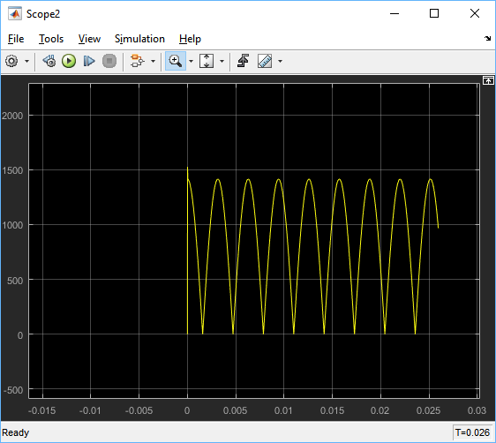

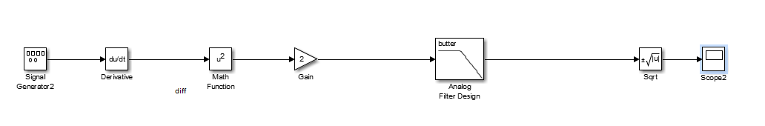

1. 5.2

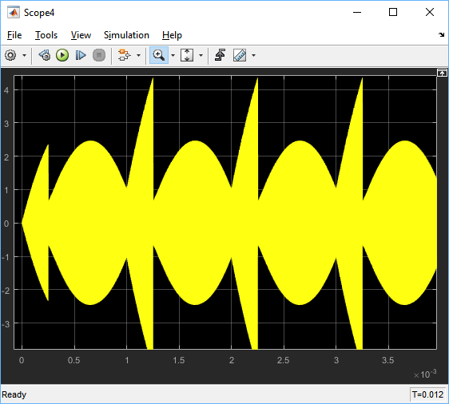

FM signal through Scope

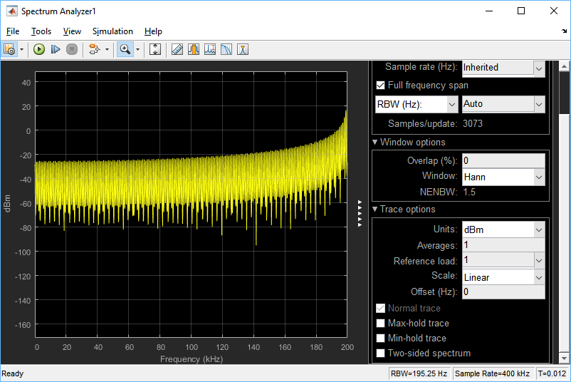

FM signal through Spectrum Analyzer

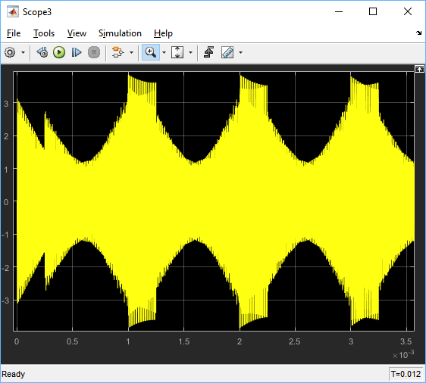

PM through Scope

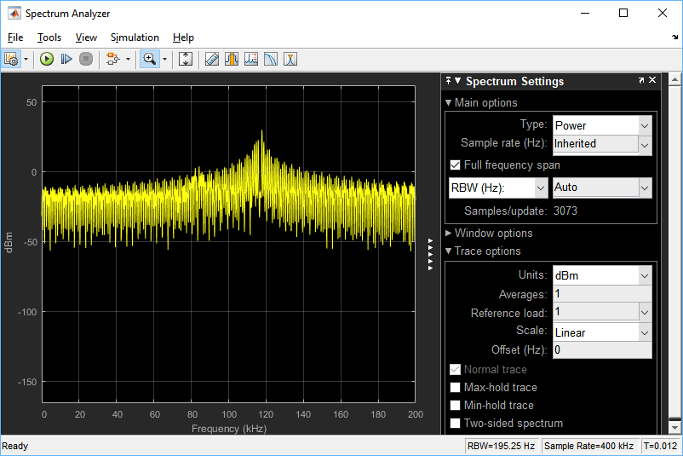

PM through Spectrum Analyzer

Matlab Code:

% EE 382

% Lab 5

%%

%Part 1

ts=1.e-4;

t=-0.04:ts:0.04;

Ta=0.01;

m_sig=triangle((t+0.01)/Ta)-triangle((t-0.01)/Ta);

Lfft=length(t); Lfft=2^ceil(log2(Lfft));

M_fre=fftshift(fft(m_sig,Lfft));

freqm=(-Lfft/2:Lfft/2-1)/(Lfft*ts);

B_m=100; %Bandwidth of the signal is B_m Hz

% Design a simple lowpass filter with bandwidth B_m Hz.

h=fir1(80,[B_m*ts]);

%

kf=80;

m_intg=kf*ts*cumsum(m_sig);

s_fm=cos(2*pi*300*t+m_intg);

s_pm=cos(2*pi*300*t+pi*m_sig);

Lfft=length(t); Lfft=2^ceil(log2(Lfft)+1);

S_fm=fftshift(fft(s_fm,Lfft));

S_pm=fftshift(fft(s_pm,Lfft));

freqs=(-Lfft/2:Lfft/2-1)/(Lfft*ts);

s_fmdem=diff([s_fm(1) s_fm])/ts/kf;

s_fmrec=s_fmdem.*(s_fmdem>0);

s_dec=filter(h,1,s_fmrec);

% Demodulation

% Using an ideal LPF with bandwidth 200 Hz

Trange1=[-0.04 0.04 -1.2 1.2];

figure(1)

subplot(211); m1=plot(t,m_sig);

axis(Trange1); set(m1, 'Linewidth',2);

xlabel('{\it t} (sec)'); ylabel('{\it m}({\it t})');

title('Message signal');

subplot(212); m2=plot(t,s_dec);

set(m2, 'Linewidth',2);

xlabel('{\it t} (sec)'); ylabel('{\it m}_d({\it t})');

title('Demodulated FM Signal');

figure(2)

subplot(211); td1=plot(t,s_fm);

axis(Trange1); set(td1, 'Linewidth',2);

xlabel('{\it t} (sec)'); ylabel('{\it s}_{\rm FM}({\it t})');

title('FM Signal');

subplot(212); td2=plot(t,s_pm);

axis(Trange1); set(td2, 'Linewidth',2);

xlabel('{\it t} (sec)'); ylabel('{\it m}_{\rm PM})({\it t})');

title('PM Signal');

figure(3)

subplot(211); fp1=plot(t,s_fmdem);

set(fp1, 'Linewidth',2);

xlabel('{\it t} (sec)'); ylabel('{\it d s}_{\rm FM}({\it t})/dt');

title('FM Derivative');

subplot(212); fp2=plot(t,s_fmrec);

set(fp2, 'Linewidth',2);

xlabel('{\it t} (sec)');

title('Rectified FM Derivative');

Frange=[-600 600 0 300];

figure(4)

subplot(211); fd1=plot(freqs,abs(S_fm));

axis(Frange); set(fd1, 'Linewidth',2);

xlabel('{\it f} (Hz)'); ylabel('{\it S}_{\rm FM}({\it f})');

title('FM Amplitude Spectrum');

subplot(212); fd2=plot(freqs,abs(S_pm));

axis(Frange); set(fd2,'Linewidth', 2);

xlabel('{\it f} (Hz)'); ylabel('{\it S}_{\rm PM}({\it f})');

title('PM Amplitude Derivative');

%%

%Part 2

ts=1.e-4;

t=-0.04:ts:0.04;

Ta=0.01;

fc=400;

sig_1=(100.*t+4).^3.*(ustep(t+0.04)-ustep(t+0.02));

sig_2=(100.*t).^3.*(ustep(t+0.02)-ustep(t-0.02));

sig_3=(100.*t-4).^3.*(ustep(t-0.02)-ustep(t-0.04));

m=(-0.125*sig_1)+(0.125*sig_2)+(-0.125*sig_3);

m_sig=m;

Lfft=length(t); Lfft=2^ceil(log2(Lfft));

M_fre=fftshift(fft(m_sig,Lfft));

freqm=(-Lfft/2:Lfft/2-1)/(Lfft*ts);

B_m=100; %Bandwidth of the signal is B_m Hz

% Design a simple lowpass filter with bandwidth B_m Hz.

h=fir1(80,[B_m*ts]);

%

kf=50*pi;

m_intg=kf*ts*cumsum(m_sig);

s_fm=cos(2*pi*fc*t+m_intg);

s_pm=cos(2*pi*fc*t+pi*m_sig);

Lfft=length(t); Lfft=2^ceil(log2(Lfft)+1);

S_fm=fftshift(fft(s_fm,Lfft));

S_pm=fftshift(fft(s_pm,Lfft));

freqs=(-Lfft/2:Lfft/2-1)/(Lfft*ts);

s_fmdem=diff([s_fm(1) s_fm])/ts/kf;

s_fmrec=s_fmdem.*(s_fmdem>0);

s_dec=filter(h,1,s_fmrec);

% Demodulation

% Using an ideal LPF with bandwidth 200 Hz

Trange1=[-0.04 0.04 -1.2 1.2];

figure(1)

subplot(211); m1=plot(t,m_sig);

axis(Trange1); set(m1, 'Linewidth',2);

xlabel('{\it t} (sec)'); ylabel('{\it m}({\it t})');

title('Message signal');

subplot(212); m2=plot(t,s_dec);

set(m2, 'Linewidth',2);

xlabel('{\it t} (sec)'); ylabel('{\it m}_d({\it t})');

title('Demodulated FM Signal');

figure(2)

subplot(211); td1=plot(t,s_fm);

axis(Trange1); set(td1, 'Linewidth',2);

xlabel('{\it t} (sec)'); ylabel('{\it s}_{\rm FM}({\it t})');

title('FM Signal');

subplot(212); td2=plot(t,s_pm);

axis(Trange1); set(td2, 'Linewidth',2);

xlabel('{\it t} (sec)'); ylabel('{\it m}_{\rm PM})({\it t})');

title('PM Signal');

figure(3)

subplot(211); fp1=plot(t,s_fmdem);

set(fp1, 'Linewidth',2);

xlabel('{\it t} (sec)'); ylabel('{\it d s}_{\rm FM}({\it t})/dt');

title('FM Derivative');

subplot(212); fp2=plot(t,s_fmrec);

set(fp2, 'Linewidth',2);

xlabel('{\it t} (sec)');

title('Rectified FM Derivative');

Frange=[-600 600 0 300];

figure(4)

subplot(211); fd1=plot(freqs,abs(S_fm));

axis(Frange); set(fd1, 'Linewidth',2);

xlabel('{\it f} (Hz)'); ylabel('{\it S}_{\rm FM}({\it f})');

title('FM Amplitude Spectrum');

subplot(212); fd2=plot(freqs,abs(S_pm));

axis(Frange); set(fd2,'Linewidth', 2);

xlabel('{\it f} (Hz)'); ylabel('{\it S}_{\rm PM}({\it f})');

title('PM Amplitude Derivative');

%%

%Part 3

ts=1.e-4;

t=-0.04:ts:0.04;

Ta=0.01;

fc=400;

sig_1=(100.*t+4).^3.*(ustep(t+0.04)-ustep(t+0.02));

sig_2=(100.*t).^3.*(ustep(t+0.02)-ustep(t-0.02));

sig_3=(100.*t-4).^3.*(ustep(t-0.02)-ustep(t-0.04));

m=(-0.125*sig_1)+(0.125*sig_2)+(-0.125*sig_3);

m_sig=m;

Lfft=length(t); Lfft=2^ceil(log2(Lfft));

M_fre=fftshift(fft(m_sig,Lfft));

freqm=(-Lfft/2:Lfft/2-1)/(Lfft*ts);

B_m=100; %Bandwidth of the signal is B_m Hz

% Design a simple lowpass filter with bandwidth B_m Hz.

h=fir1(80,[B_m*ts]);

%

kf=50*pi;

m_intg=kf*ts*cumsum(m_sig);

s_fm=cos(2*pi*fc*t+m_intg);

s_pm=cos(2*pi*fc*t+0.5*pi*m_sig);

Lfft=length(t); Lfft=2^ceil(log2(Lfft)+1);

S_fm=fftshift(fft(s_fm,Lfft));

S_pm=fftshift(fft(s_pm,Lfft));

freqs=(-Lfft/2:Lfft/2-1)/(Lfft*ts);

s_fmdem=diff([s_fm(1) s_fm])/ts/kf;

s_fmrec=s_fmdem.*(s_fmdem>0);

s_dec=filter(h,1,s_fmrec);

% Demodulation

% Using an ideal LPF with bandwidth 200 Hz

Trange1=[-0.04 0.04 -1.2 1.2];

figure(1)

subplot(211); m1=plot(t,m_sig);

axis(Trange1); set(m1, 'Linewidth',2);

xlabel('{\it t} (sec)'); ylabel('{\it m}({\it t})');

title('Message signal');

subplot(212); m2=plot(t,s_dec);

set(m2, 'Linewidth',2);

xlabel('{\it t} (sec)'); ylabel('{\it m}_d({\it t})');

title('Demodulated PM Signal');

figure(2)

subplot(211); td1=plot(t,s_fm);

axis(Trange1); set(td1, 'Linewidth',2);

xlabel('{\it t} (sec)'); ylabel('{\it s}_{\rm FM}({\it t})');

title('FM Signal');

subplot(212); td2=plot(t,s_pm);

axis(Trange1); set(td2, 'Linewidth',2);

xlabel('{\it t} (sec)'); ylabel('{\it m}_{\rm PM})({\it t})');

title('PM Signal');

figure(3)

subplot(211); fp1=plot(t,s_fmdem);

set(fp1, 'Linewidth',2);

xlabel('{\it t} (sec)'); ylabel('{\it d s}_{\rm FM}({\it t})/dt');

title('PM Derivative');

subplot(212); fp2=plot(t,s_fmrec);

set(fp2, 'Linewidth',2);

xlabel('{\it t} (sec)');

title('Rectified PM Derivative');

Frange=[-600 600 0 300];

figure(4)

subplot(211); fd1=plot(freqs,abs(S_fm));

axis(Frange); set(fd1, 'Linewidth',2);

xlabel('{\it f} (Hz)'); ylabel('{\it S}_{\rm FM}({\it f})');

title('FM Amplitude Spectrum');

subplot(212); fd2=plot(freqs,abs(S_pm));

axis(Frange); set(fd2,'Linewidth', 2);

xlabel('{\it f} (Hz)'); ylabel('{\it S}_{\rm PM}({\it f})');

title('PM Amplitude Derivative');